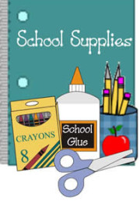
Third Graders’ Supply List 2023-24
Welcome to 3rd grade! To help families plan ahead and get prepared for 3rd Grade before the first day, here is a list of items needed for 3rd Grade. We hope that you can use this list to gather school supplies before school begins. Enjoy the rest of your summer break. See you soon in 3rd Grade! -The Third Grade Teachers J
- Backpack
- Large CANVAS Pencil Pouch- To hold our pencils, glue sticks, crayons, and other small items. DO NOT send plastic pencil boxes, please.
- Folders- Students will use (2) different colored propylene (plastic) pocket folders with binder holes.
- Colored Pencils (8 or 12 count)- Colored pencils will help students complete their class assignments.
- Thin Colored Crayola Markers (8 or 12 count)
- One Pair of FISKERS child scissors
- Crayola Crayons (24 count)- For great opportunities for students to be creative.
- 1 Single Subject Spiral Notebook
- 1 Water Bottle LABEL WITH NAME - Suitable for refilling and daily use
- Earbuds or headphones
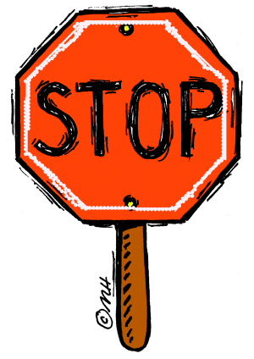PLEASE DO NOT SEND: *Post-It Notes or Stickers, *Ink Pens, *Highlighters, *Thick washable or permanent Markers, *Pencil Boxes

CLASSROOM DONATION SUPPLIES: Your donations mean so much….Thank you! We can use the following supplies for our classrooms: JKleenex & Paper Towels,
JBoxes of No. 2 Pencils,
JMultipacks of Glue Sticks,
JBaby Wipes or Clorox Wipes

