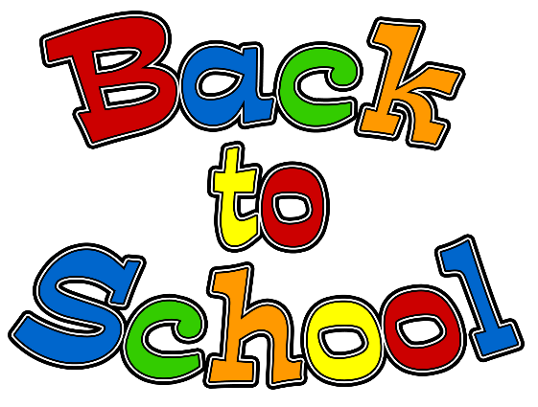

*For School:
- Headphones – Please make sure they comfortably fit your child and work well. Also, send them in a gallon bag with your child’s name on it.
- water bottle (One that can close completely and won’t leak, but that can be opened easily to refill.) Please label waterbottle.
- backpack
* ALL items belonging to your child (headphones, backpack, coats, etc.) must be clearly labeled with his or her first and last name. This is very important!
* At Home Items: (We will provide these for your child in school, but it would be good for your child to have these available to use at home.)
- Crayons (24 pack regular)
- pencils
- block or pencil-top erasers
- glue stick
- scissors
We would gladly take donations of the following for the classroom…
- Individual cans of Play-doh
- Pack of 12” x 18” construction paper
- Tissue
- Clorox wipes
We will see you soon!
Thank you! - Mrs. Smith, Mr. Wastchak, and Miss Yanchik

